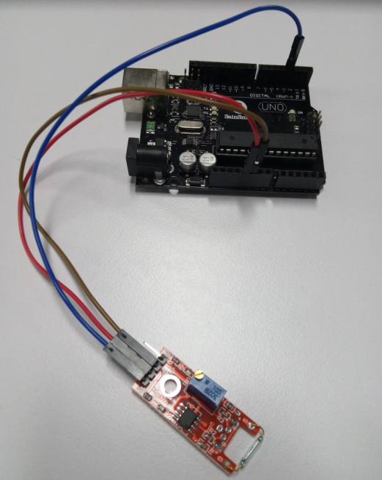

int Led = 13 ;// define LED Interface

int buttonpin = 3; // define the Reed sensor interfaces

int val ;// define numeric variables val

void setup ()

{

pinMode (Led, OUTPUT) ;// define LED as output interface

pinMode (buttonpin, INPUT) ;// output interface as defined Reed sensor

}

void loop ()

{

val = digitalRead (buttonpin) ;// digital interface will be assigned a value of 3 to read val

if (val == HIGH) // When the Reed sensor detects a signal, LED flashes

{

digitalWrite (Led, HIGH);

}

else

{

digitalWrite (Led, LOW);

}

}